Grade 7 Accelerated · Unit 4 · Lesson 5  Evaluating Expressions with Radicals  Question Bank - Additional 4.05 ANSWER KEY | Name  Date  Period

Show your work. Circle your final answer.
For questions 1 through 6, evaluate.
1. 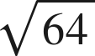
8

2. 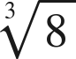
2

3. 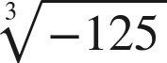
−5
An odd root keeps the sign of its radicand.

4. 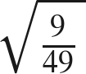
Top and bottom each get the root.

5. 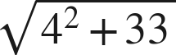
7
16 + 33 = 49.

6. 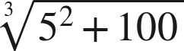
5
25 + 100 = 125.

For questions 7 and 8, evaluate. Each expression has a power and a radical.
7. Evaluate each expression.
a. 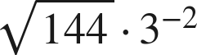
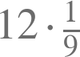.
b. 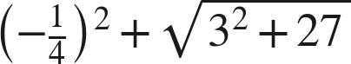

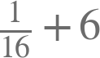.
c. 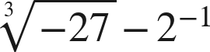
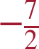
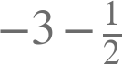.

8. Evaluate each expression.
a. 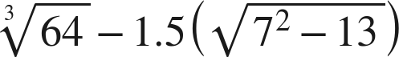
−5
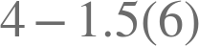.
b. 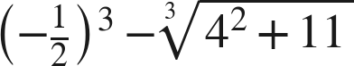
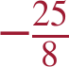
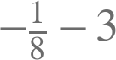.
c. 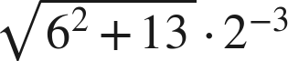
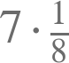.

Working backwards.
9. Find the value of that makes each statement true. (The radicand is the unknown here, so it is not one of the listed perfect values until you find it.)
a. 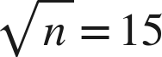
n = 225
b. 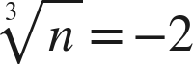
n = −8
c. 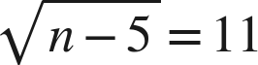
n = 126
.

Reading someone else's work.
10. Deshawn writes . Evaluate the expression correctly, and explain in one sentence what the radical bar does that his method ignores.
. The bar groups the subtraction into a single radicand, so it is finished before any root is taken; the root of a difference is not the difference of the roots.
His answer is half the true value. Ask him to try 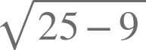: his method gives 2 and the value is 4.

11. Which is the value of 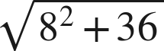 ?
○ A. 14
● B. 10
○ C. 100
○ D. 50
B

12. Select ALL of the expressions whose value is 4.
☐ A. 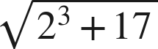
☒ B. 
☐ C. 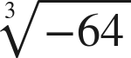
☒ D. 
☒ E. 
☒ F. 
B, D, E and F

